**InvoSale** is a comprehensive software solution which was developed by Abreham Gebremedin Debele that can assist in the management of your inventory, accounting, and human resource management (HRM). It's suitable for both wholesale and retail businesses and considered an excellent product for Super Shops. This user-friendly software is fully responsive and has a plethora of features to help manage your business inventory efficiently. The Inventory Management System with POS, HRM, and Accounting is a comprehensive software solution that integrates several business operations into one platform. It includes a Point of Sale (POS) module to efficiently manage sales transactions, a Human Resource Management (HRM) module to handle employee records and payroll, and an Accounting module to keep track of financial data. The system provides real-time updates on inventory levels, enabling businesses to make informed decisions on stock management. The HRM module streamlines employee management and reduces manual labor while the Accounting module facilitates financial reporting. This integrated system streamlines business processes and enhances efficiency by eliminating manual data entry, reducing errors, and providing a unified view of the business operations.

Basically the software has two theme (background color) white and black

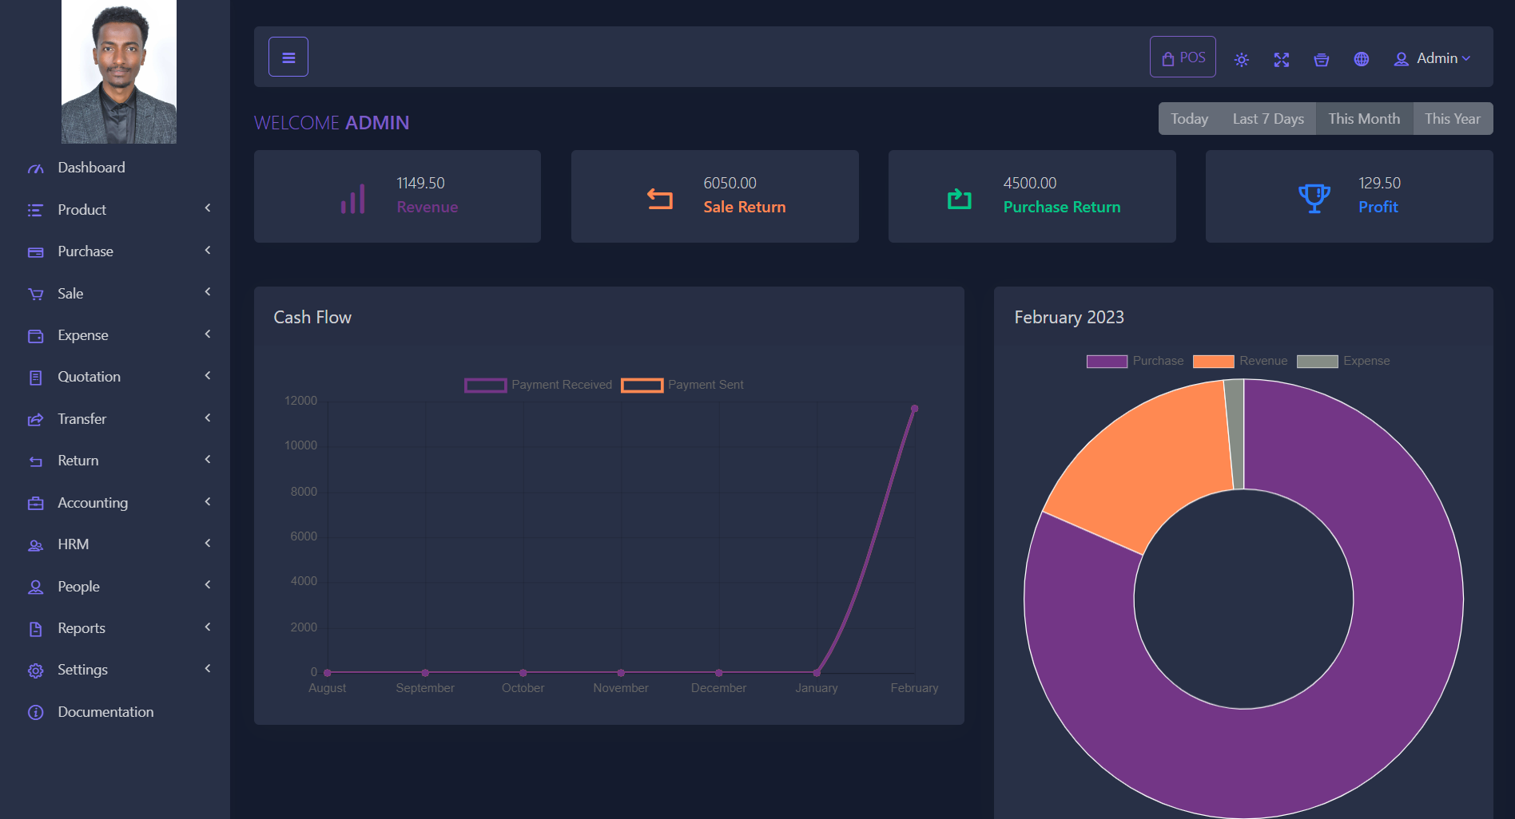

### DASHBOARD

Our customers are provided with a beautiful dashboard where they can quickly access information regarding Revenue, Sale Return, Purchase Return, and Profit for the current day, last 7 days, current month, and current year with just one click.

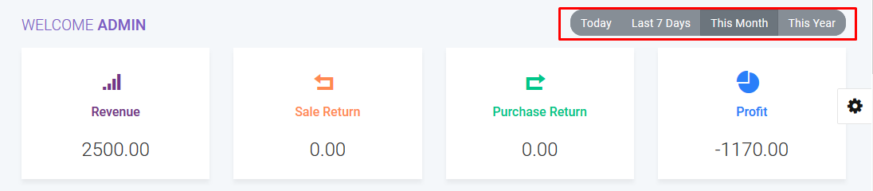

The line chart provides you with insights into your cash flow, showing you how much money you are earning and how much you are spending.

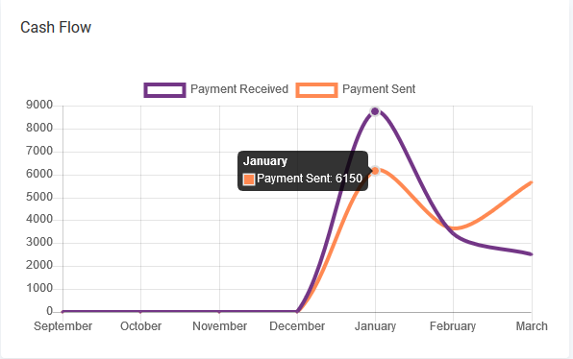

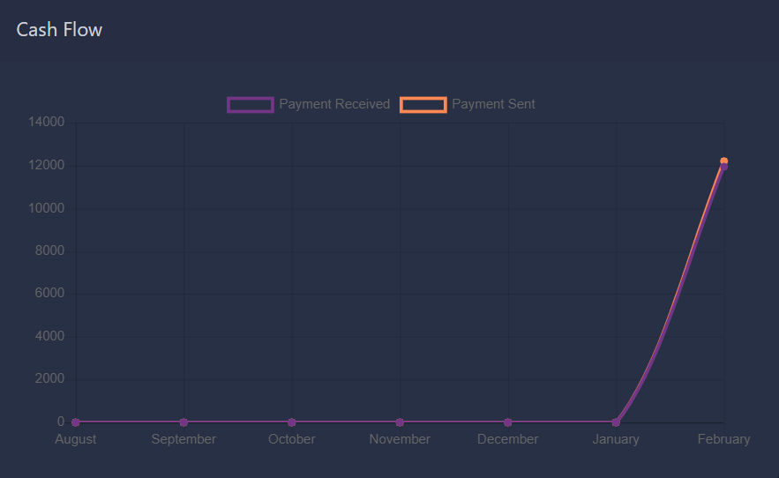

The doughnut chart gives you a visual representation of your current month's purchases and expenditures, allowing you to stay informed about your revenue.

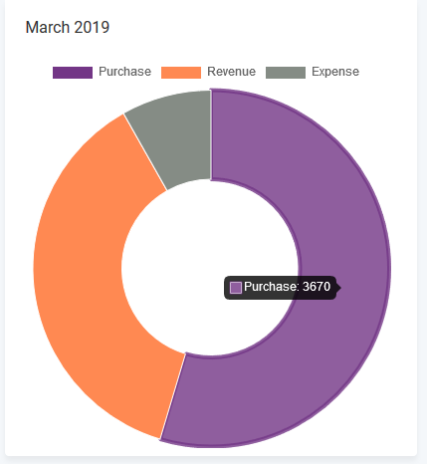 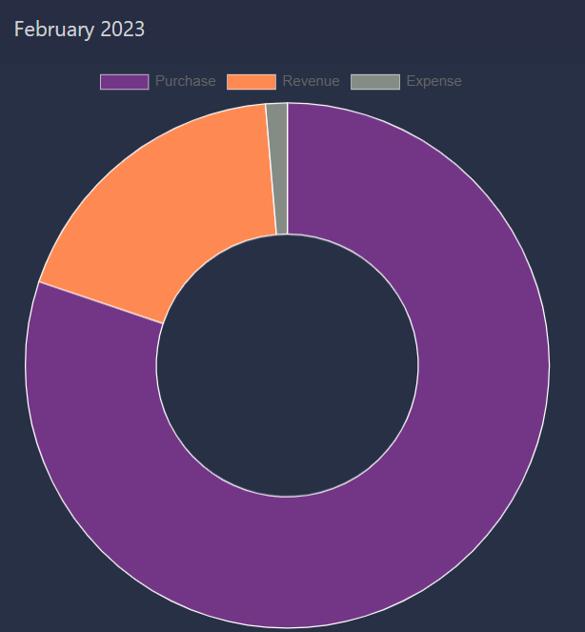

A bar graph depicts the annual report of both purchases and sales for the current year.

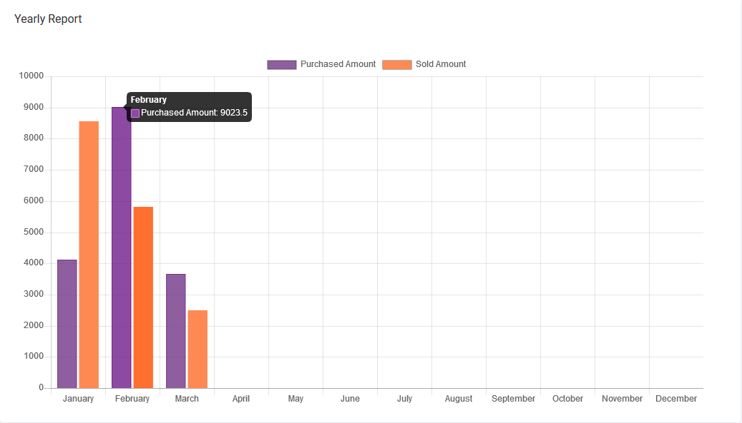

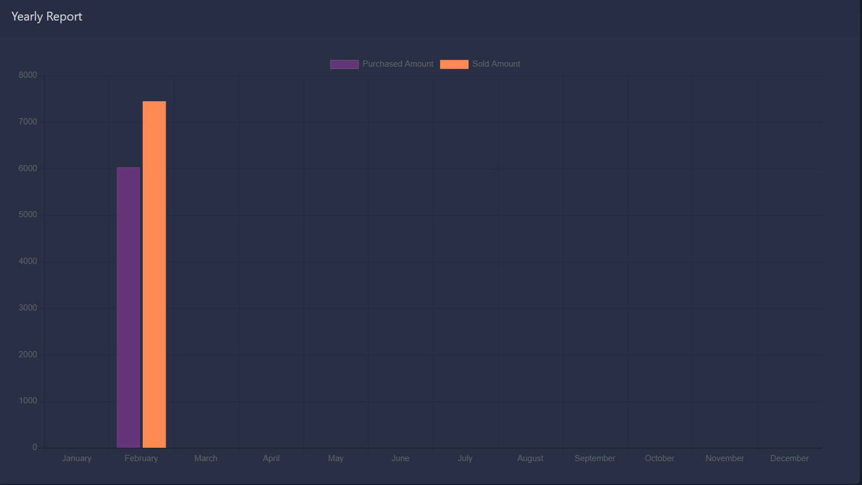

The dashboard provides you with up-to-date information on recent transactions, including sales, purchases, quotations, and payments, as well as the top 5 best-selling products for the current month and year.

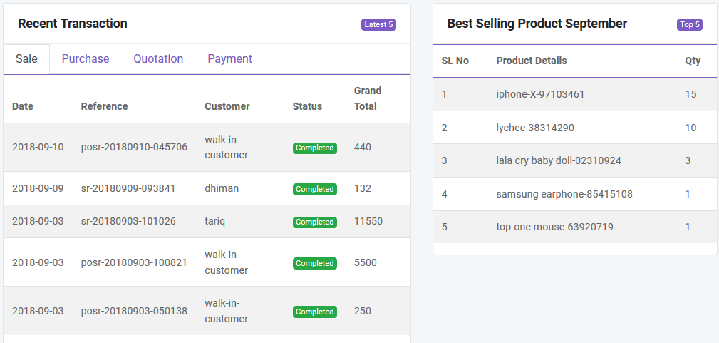

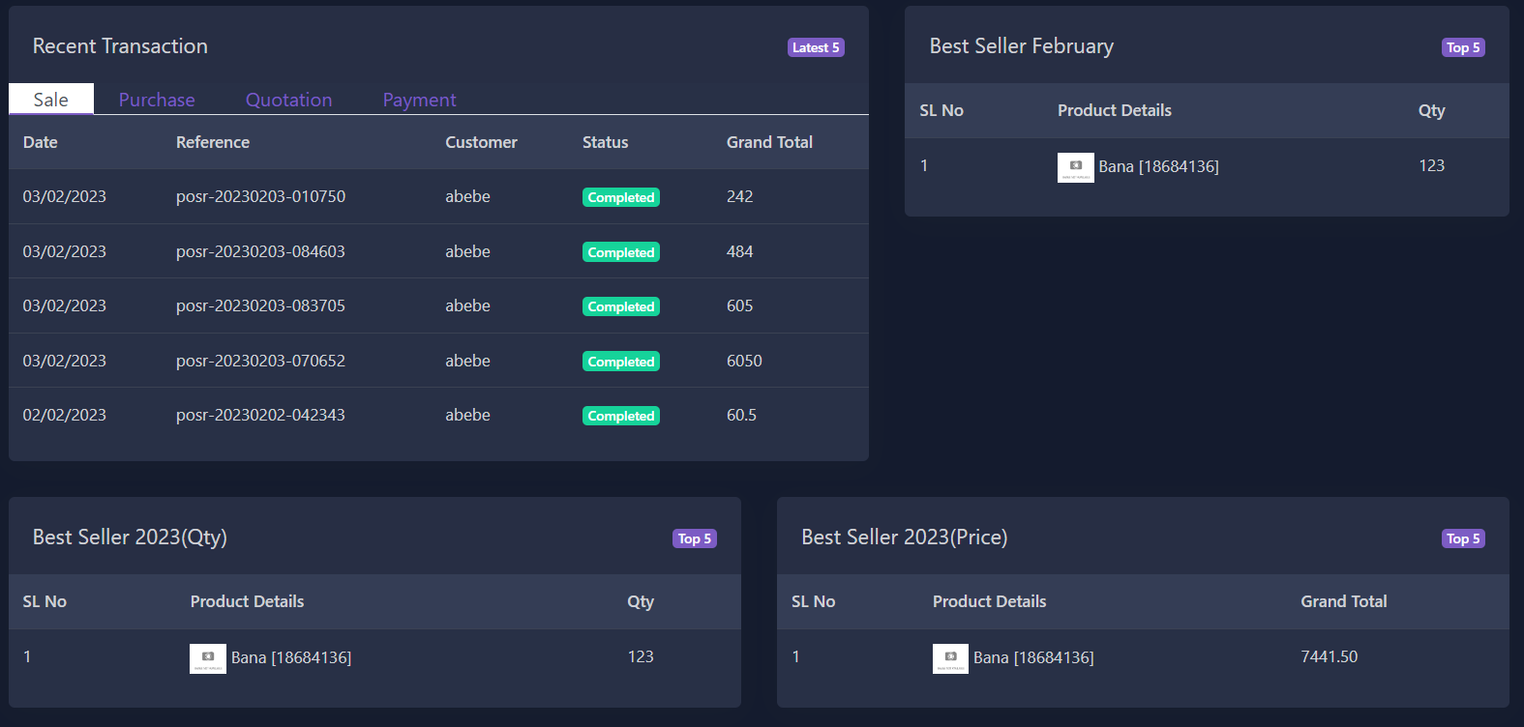

### PRODUCT

## ****Category****

You can add, edit and delete product category. You can also import category from CSV file and export table data to PDF and CSV. Also you can print data from table.

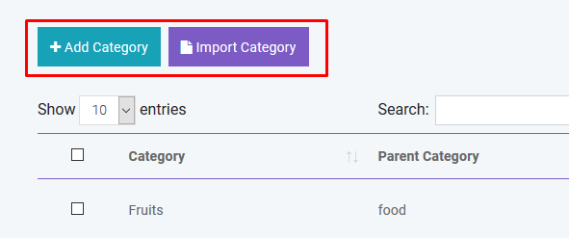   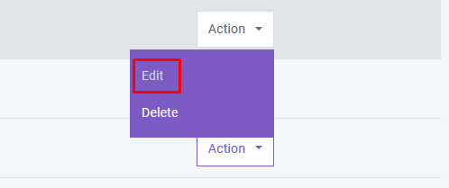

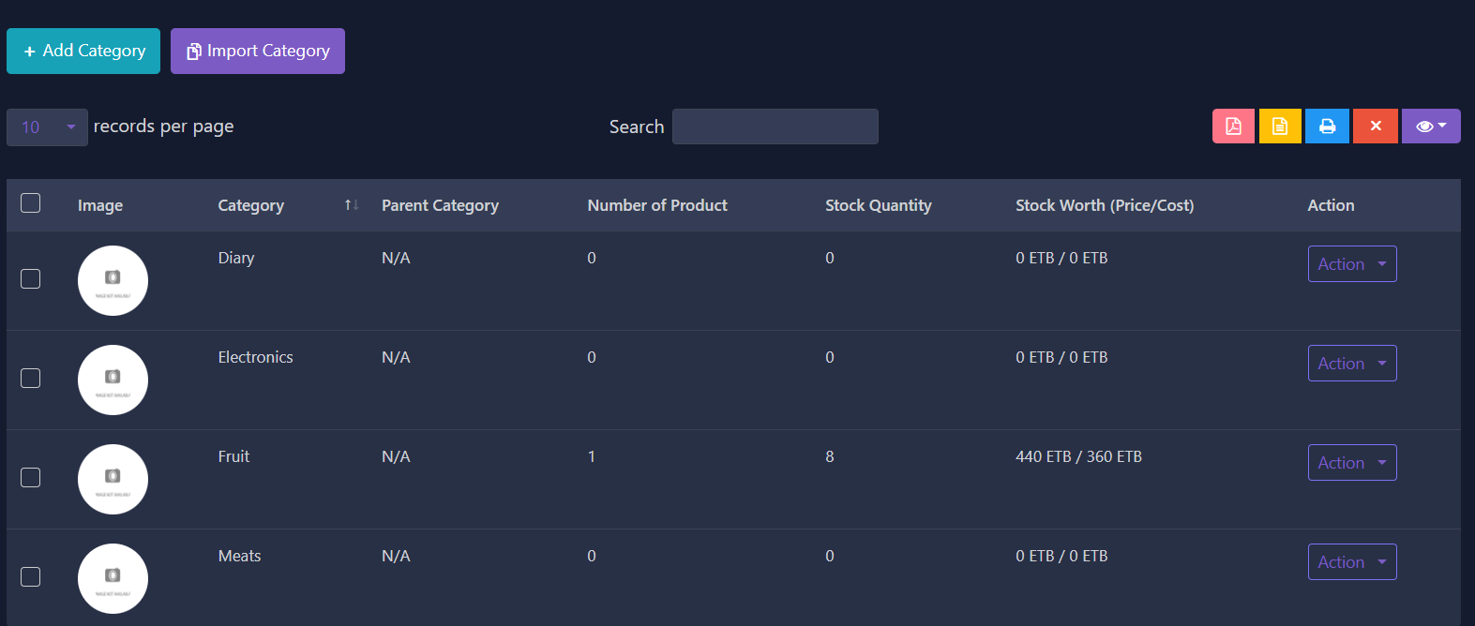

You have the option to omit any column from being exported by clicking the Column Visibility button. This will allow you to select which columns you want to remove from the table.

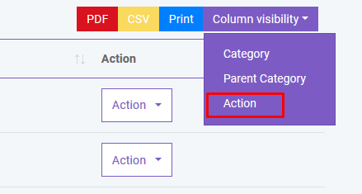   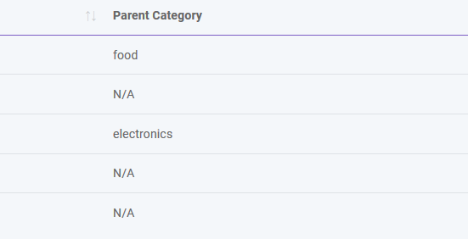

To export data from specific row you just have to check the checkbox of the related row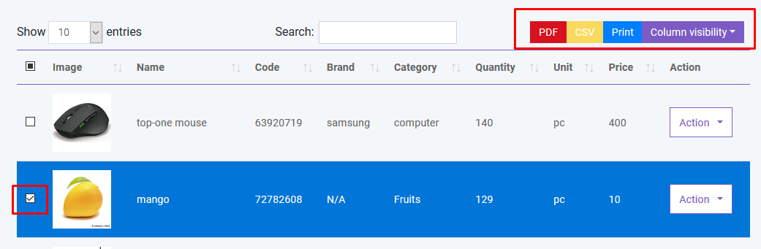

If you want to delete all the row from table you can do this very easily as shown below. You can also delete specific row from table.

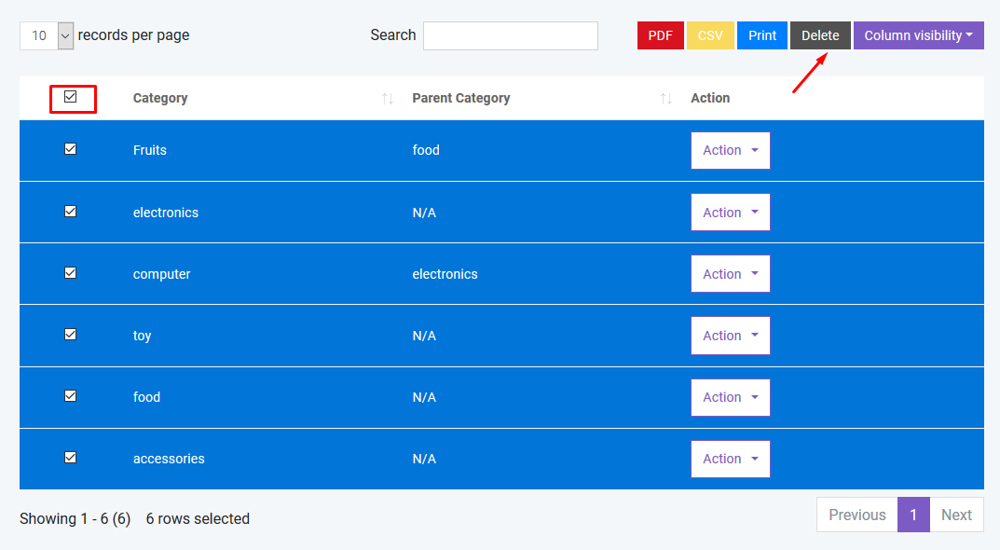

If you want to search anything from the table you can simply type the word in the search box.

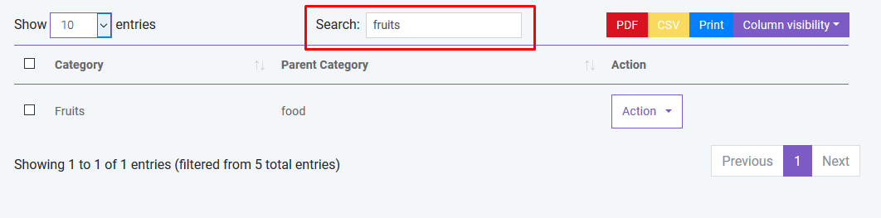

You can also control the pagination from **Show** dropdown.

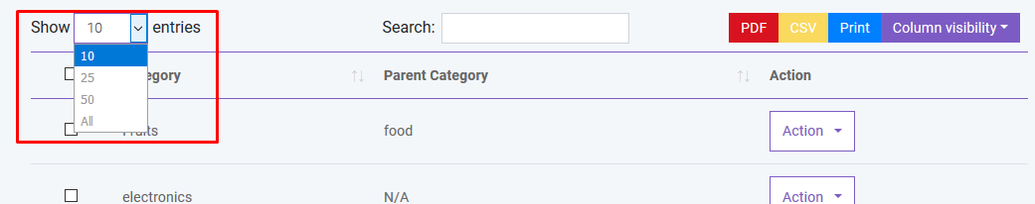

## ****Product****

In product section you will just add general information of a product. **To add stock you have to purchase that product.** You can create three types of product in InvoSale.

* Standard
* Digital
* Combo (Combination of standard product. Like mango juice is a combo product as it is consist of mango and sugar ).

You can add, edit and delete product. You can import product from CSV. **You must follow the instruction to import data from CSV**. To get better understanding you can download the sample file.

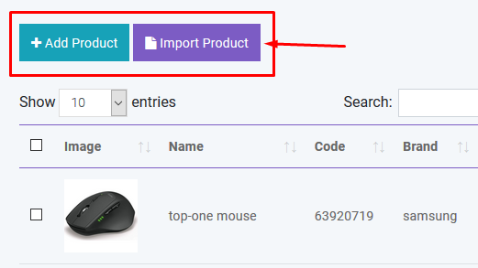   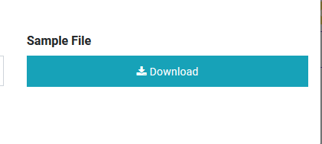

You can sort table data according to column

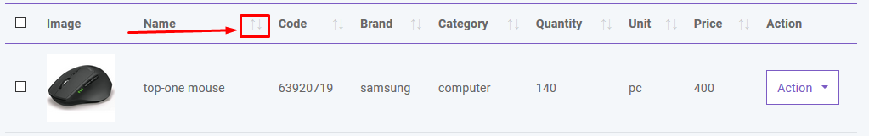

And you can search, export and print data from table that we discussed earlier in greater detail.

### ADDING STOCK

In **Product** section you just added general information of product. So where the stock comes from? To add stock you have to purchase that product for specific warehouse. This software is pretty smart that it will automatically update the stock quantity and you don't have to worry about it.

### PURCHASE

## ****Add Purchase****

You can create purchase in Purchase module. **By creating purchase the stock quantity of product will be increased.** .There are three purchase status: Recieved, Partial, Pending, Orderd. You can add product to order table by typing or scanning barcode of product.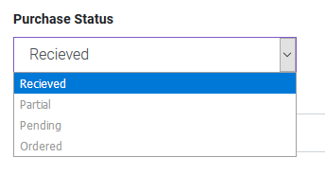   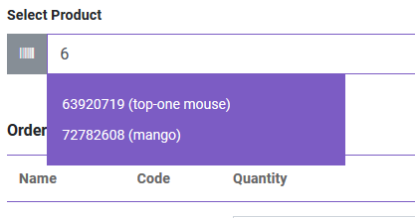

You can also edit product info from order table.

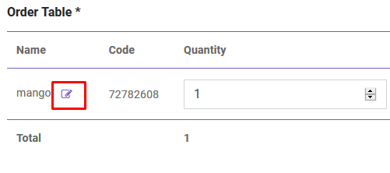

After creating purchase you will be redirected to purchase index page. You will get summary of purchase from table. To get details you just have to click in the table row.

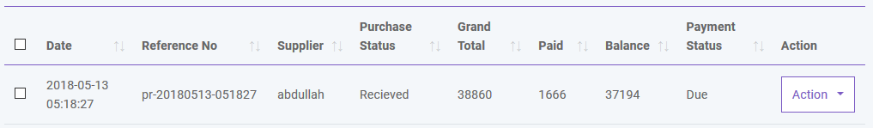

## ****Import Purchase****

You can import sale from CSV.**You must follow the instruction to import data from CSV**. To get better understanding you can download the sample file.

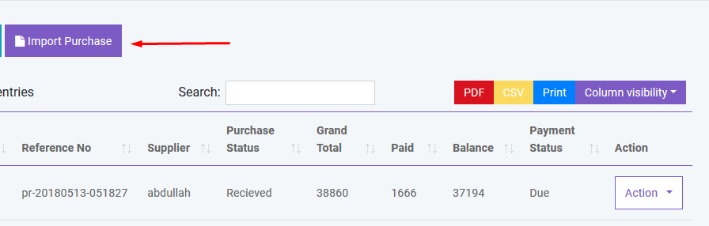

## ****Payment****

You can make payment from Purchase table. You can make payment with Cash, Gift Card, Cheque, 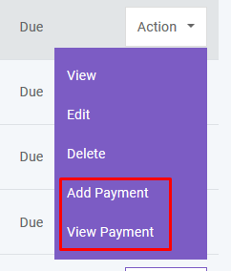   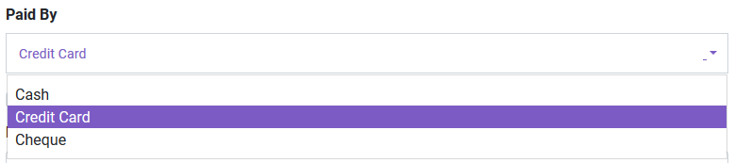

And you can search, export and print data from table that we discussed in [Product](http://localhost:85/Invosale/public/read_me/#product) section.

### SALE

## ****POS****

You can create sale from POS. Customer, Warehouse and Biller (representative of your company) will be automatically selected according to POS Settings under [Settings](http://localhost:85/Invosale/public/read_me/#setting) module. Touch screen **keybord** is activated in POS module. You can add product to order table by typing or scanning barcode of product. Featured Product will be displayed in the right side. You can also add product by clicking product image. You can edit product info from order table.

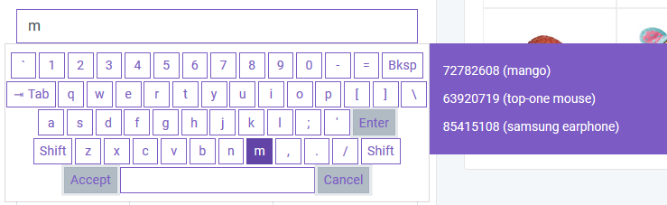 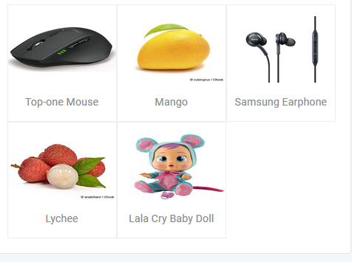   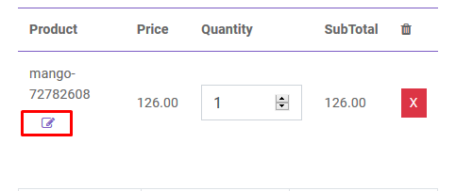

To add order discount, order tax and shipping cost you just have to click the button that are shown below. To finalize the sale you have to click the **Payment** button.

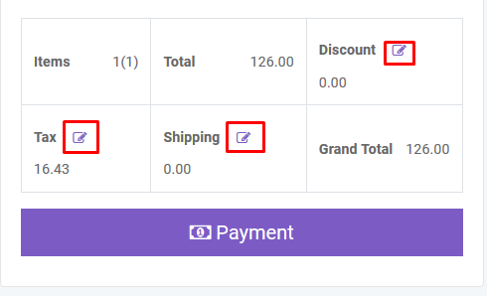

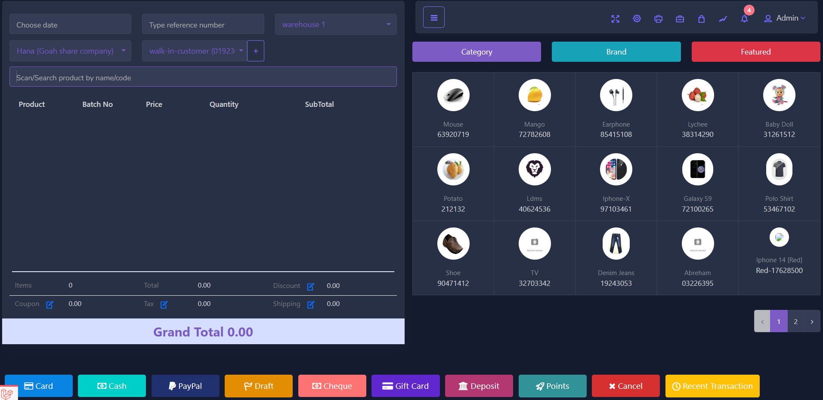

After creating sale you will be redirected to sale index page. A confirmation mail will be sent automatically to customer's email with sale details. You will get summary of sale from table. To get details you just have to click in the table row.

You can also generate **Invoice** automatically which is **beautifully** designed

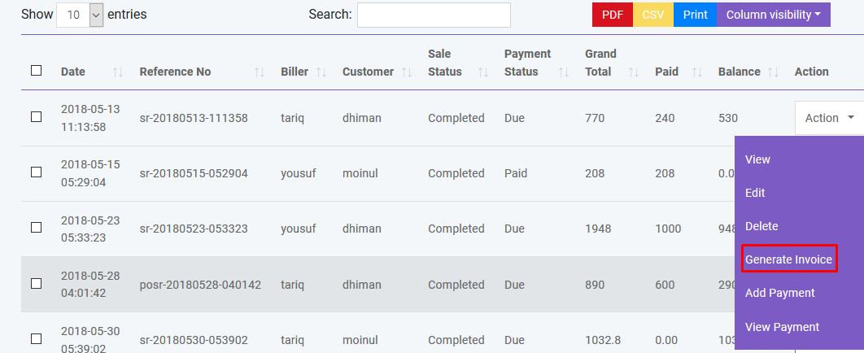

You can also create sale by clicking Add Sale button. Also you can import sale from CSV.**You must follow the instruction to import data from CSV**. To get better understanding you can download the sample file.

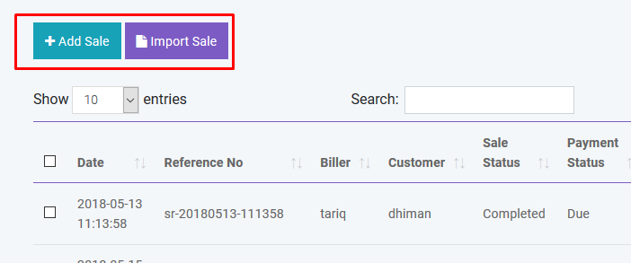

## ****Payment****

You can make payment from Sale table. You can make payment with Cash, Cheque, Credit Card, Gift Card, Deposit and Paypal. A confirmation mail will be sent automatically to customer's email with payment details.

   

And you can search, export and print data from table that we discussed in [Product](http://localhost:85/Invosale/public/read_me/#product) section.

## ****Delivery****

You can add delivery for your sold products. A confirmation mail will be sent automatically to customer's email with delivery details.

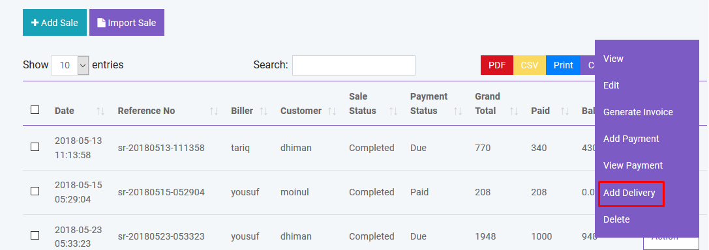

And you can search, export and print data from table that we discussed in [Product](http://localhost:85/Invosale/public/read_me/#product) section.

## ****Gift Card****

You can sell GiftCard to customer. By using gift card customer can purchase product. Again GiftCard can be recharged. Customer will be notified by mail when assigning or recharging a GiftCard.

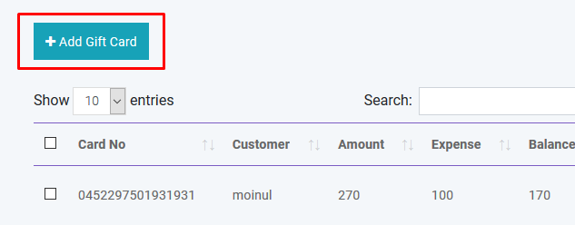   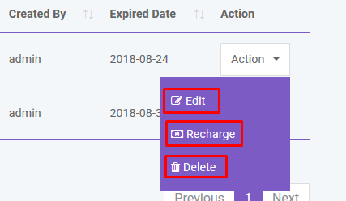

### EXPENSE

## ****Expense Category****

You can create, edit and delete expense category in Expense module.

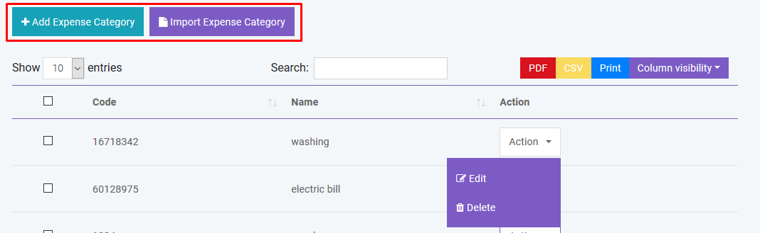

## ****Expense****

You can create, edit and delete expense in Expense module.

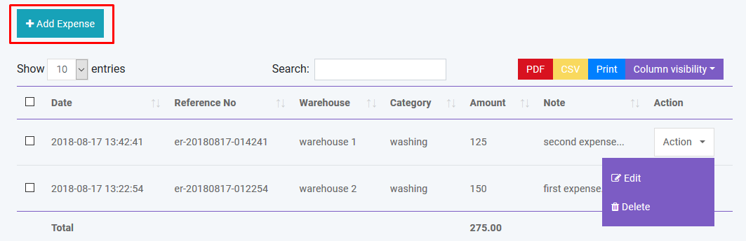

And you can search, export and print data from table that we discussed in [Product](http://localhost:85/Invosale/public/read_me/#product) section.

### QUOTATION

## ****Add Quotation****

You can create quotation in Quotation module. There are two quotation status: Pending and Sent

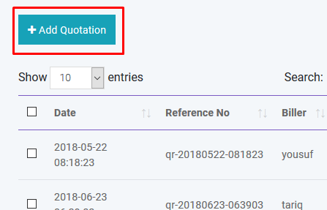

If quotation status is **Sent** a confirmation mail will be sent automatically to customer's email with quotation details.

## ****Create Sale****

You can create sale from Quotation.

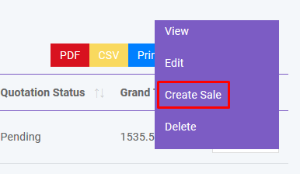

## ****Create Purchase****

You can create purchase from Quotation.

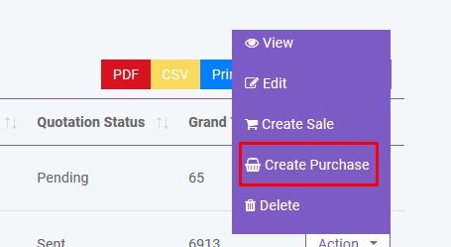

And you can search, export and print data from table that we discussed in [Product](http://localhost:85/Invosale/public/read_me/#product) section.

### QUANTITY ADJUSTMENT

## ****Add Adjustment****

You can adjust product quantity in Quantity Adjustment module. There will be two operation: Subtraction and Addition

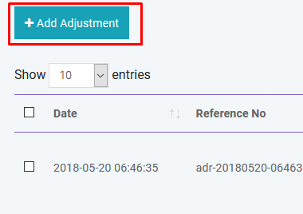 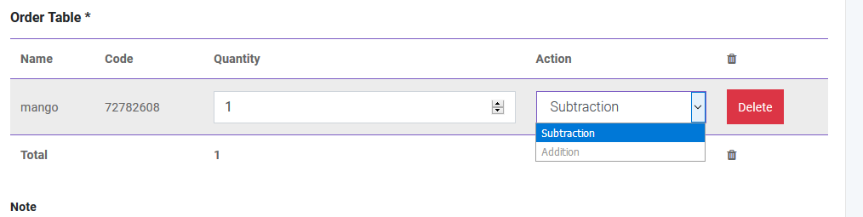

And you can search, export and print data from table that we discussed in [Product](http://localhost:85/Invosale/public/read_me/#product) section.

### STOCK COUNT

You can count your stock from this module. Two types are available: **Full** and **Partial**. In Partial type user have to specify brand and category and the software will automatically count the stock for that brand or category. Then this information will be written in CSV file which you have to download to finalize the stock count. Please follow the instruction properly. After finalizing the stock count you can automatically adjust the quantity of products if it is necessary.

### TRANSFER

## ****Add Transfer****

You can transfer your product from one warehouse to another in Transfer module. You can also transfer product with CSV file. **You must follow the instruction to import data from CSV.** To get better understanding you can download the sample file. You will get details of transfer by clicking in the table row.

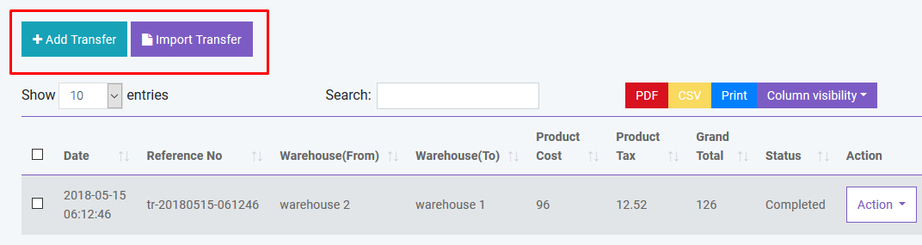

And you can search, export and print data from table that we discussed in [Product](http://localhost:85/Invosale/public/read_me/#product) section.

### RETURN

## ****Add Return****

You can return your product with Return module. You can track return of both purchase and sale with this module. A confirmation mail will be sent automatically to customer's email with return details if customer refund products. Again if you return product to supplier a confirmation mail will be sent automatically to supplier's email with return details. You will get details of return by clicking in the table row.

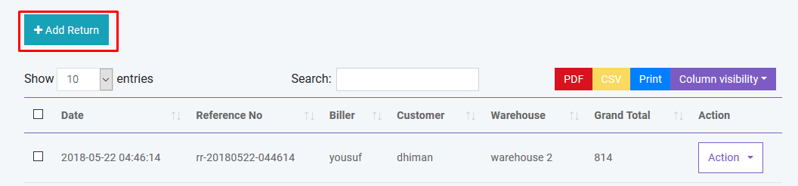

And you can search, export and print data from table that we discussed in [Product](http://localhost:85/Invosale/public/read_me/#product) section.

### Accounting

## ****Bank Account****

You can create, edit and delete account to link all your transactions. You can also set default account for sale. All the payments must be done under an account.

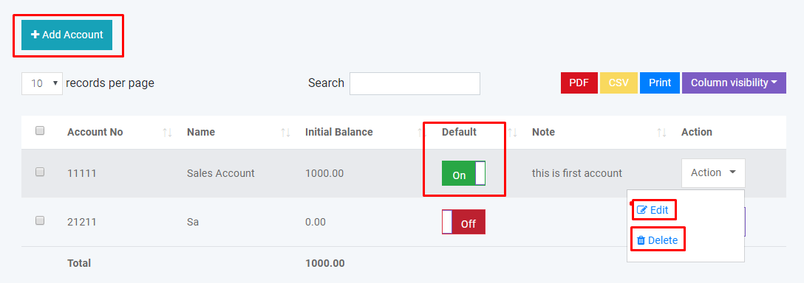 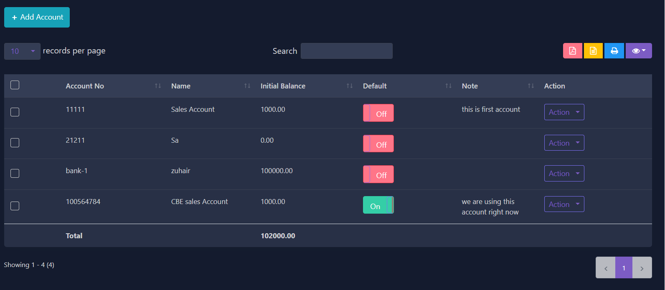

* **Balance Sheet** 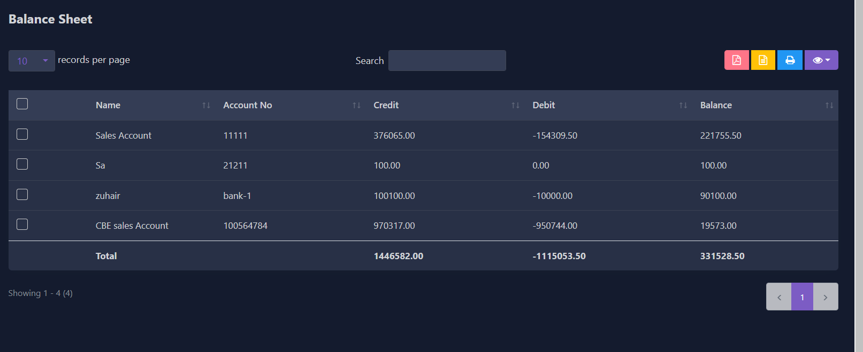
* **Account Statement** 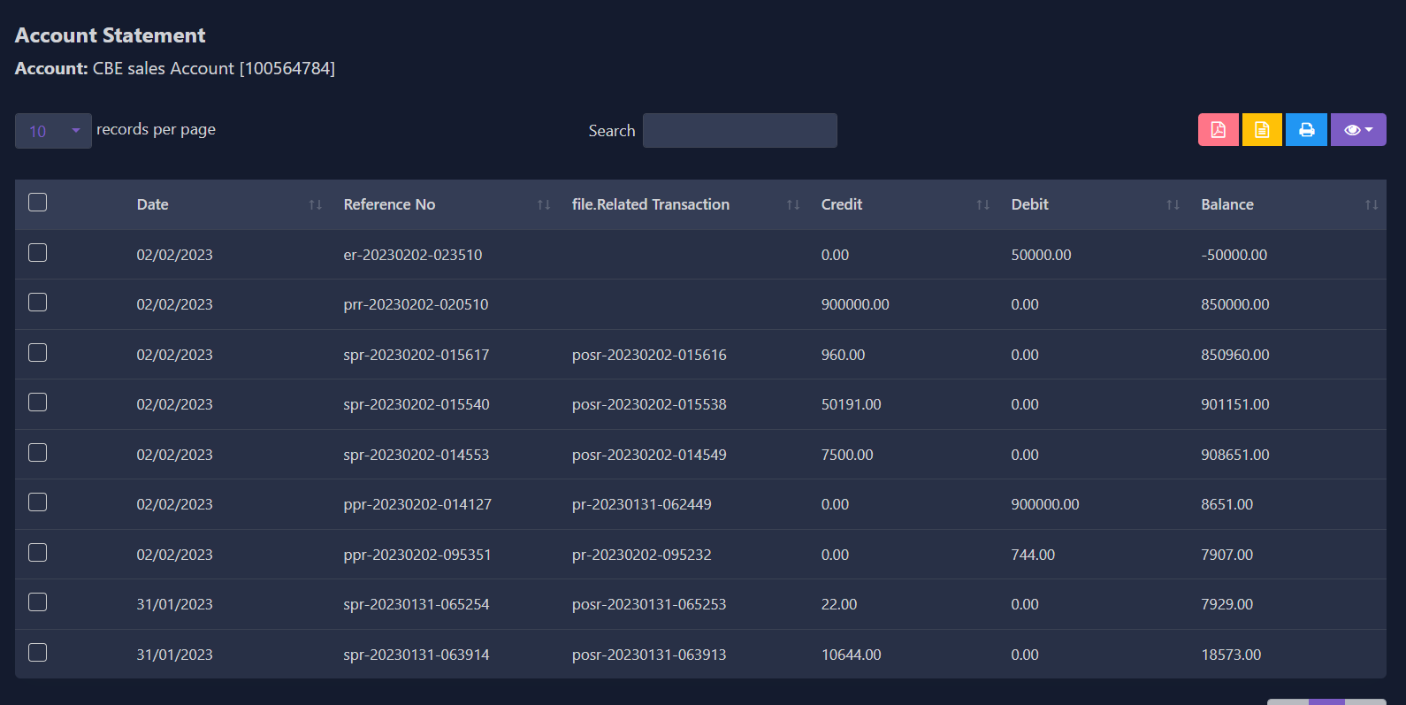

You can generate **Balance Sheet** of your accounts. You can also make **Account Statement** of an specific account to see all the transactions which has done with this account.

### HRM

## ****Department****

You can create,edit and delete department of your company.

## ****Employee****

You can create,edit and delete employee of your company. You can also give user access to employee.

## ****Attendance****

You can take employee attendance with this software. You can set CheckIn and CheckOut time in HRM Setting option under Setting Module.

## ****Payroll****

You can make payroll of your employee with this software. All payroll must be done from an specipic account.

### PEOPLE

## ****Add User****

You can create, edit and delete user account. By creating user account password will be sent to the user's email that is given. Again you can active or inactive a user.

There is also be a register option to create user account. But his/her ID will not be activated untill admin will approve it.

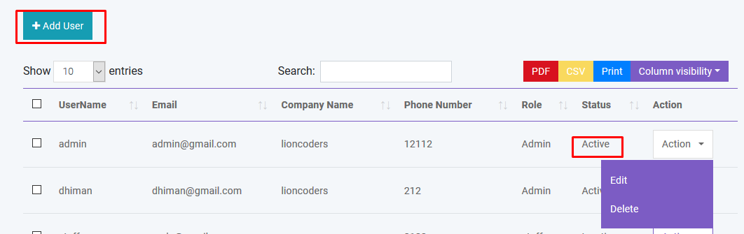

## ****Add Customer****

You can create, edit and delete customer. After creating customer a confirmation email will automatically send to customer. You can add money to customer's database just like a bank account. You can also import customer with CSV file. **You must follow the instruction to import data from CSV.**

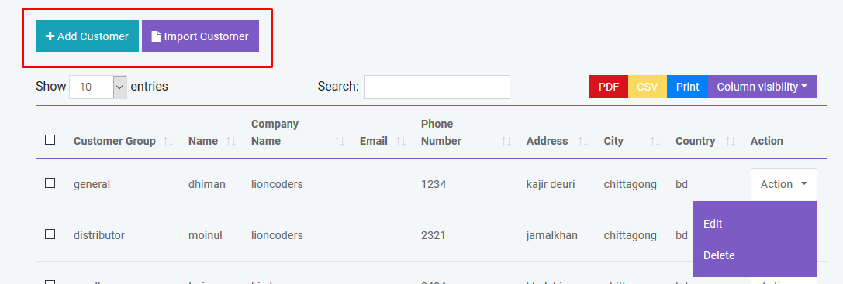

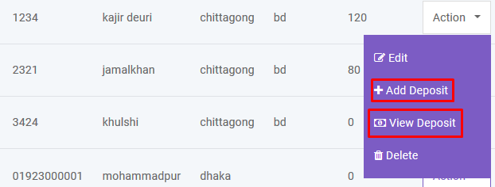

## ****Add Biller****

Biller is the representative of your company. You may have multiple company and you want to manage all your inventory from a single platform. So this is a solution for enterprise. You can create, edit and delete biller. After creating biller a confirmation email will automatically send to biller. You can also import biller with CSV file. **You must follow the instruction to import data from CSV.**

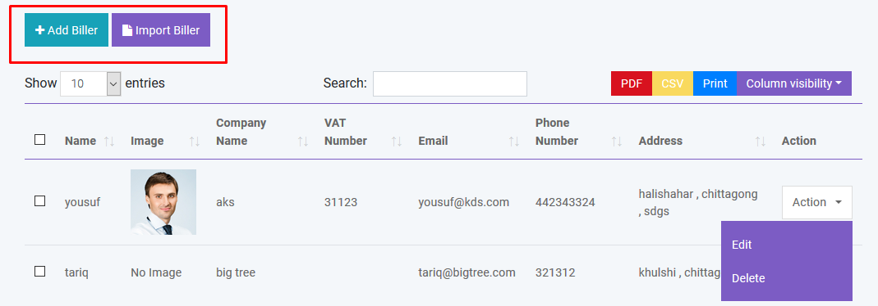

## ****Add Supplier****

Supplier is the people from whom you purchase products. You can create, edit and delete supplier. After creating supplier a confirmation email will automatically send to supplier. You can also import supplier with CSV file. **You must follow the instruction to import data from CSV.**

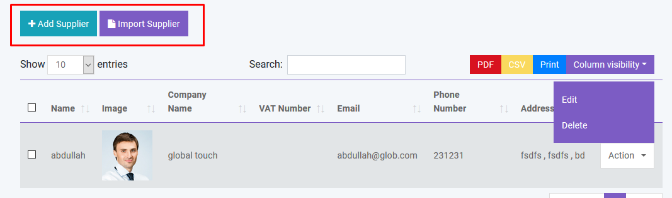

And you can search, export and print data from table that we discussed in [Product](http://localhost:85/Invosale/public/read_me/#product) section.

### Reports

You can create generate various reports automatically by using InvoSale.

* **Profit / Loss Report**
* 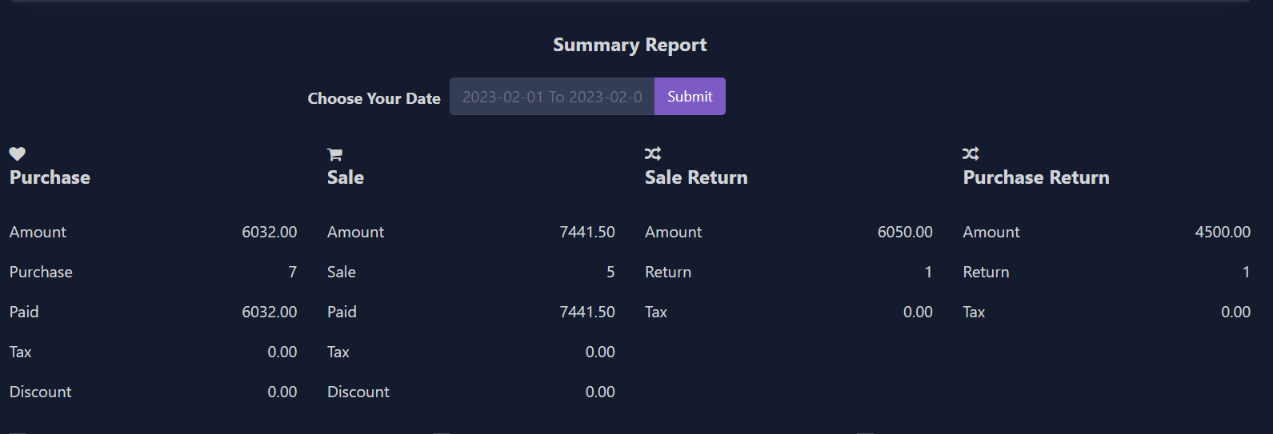 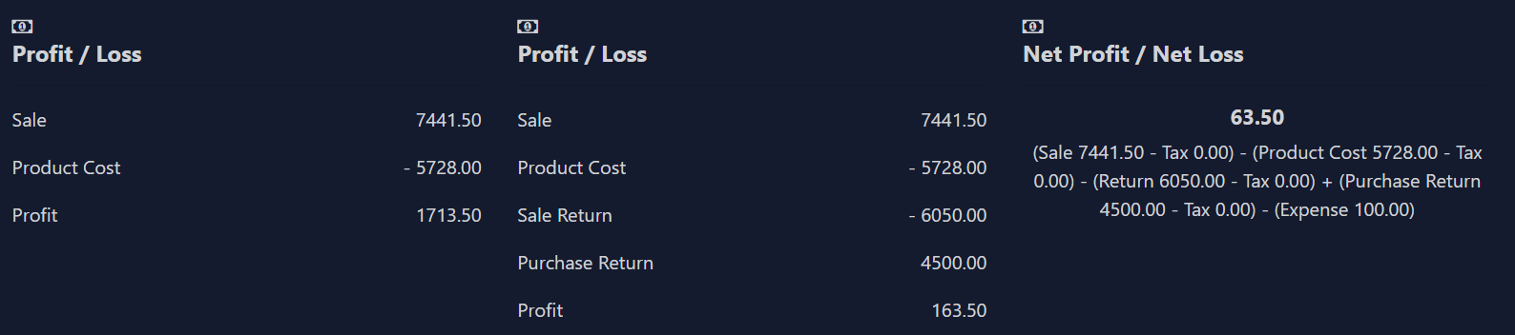
* 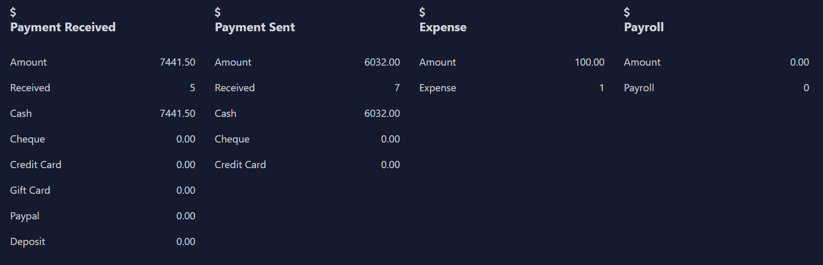  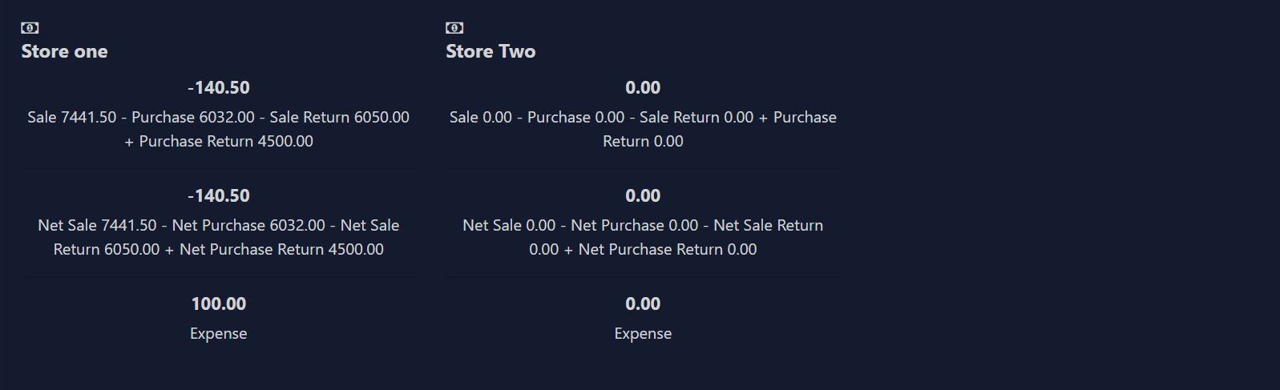
* **Best Seller Report**
* 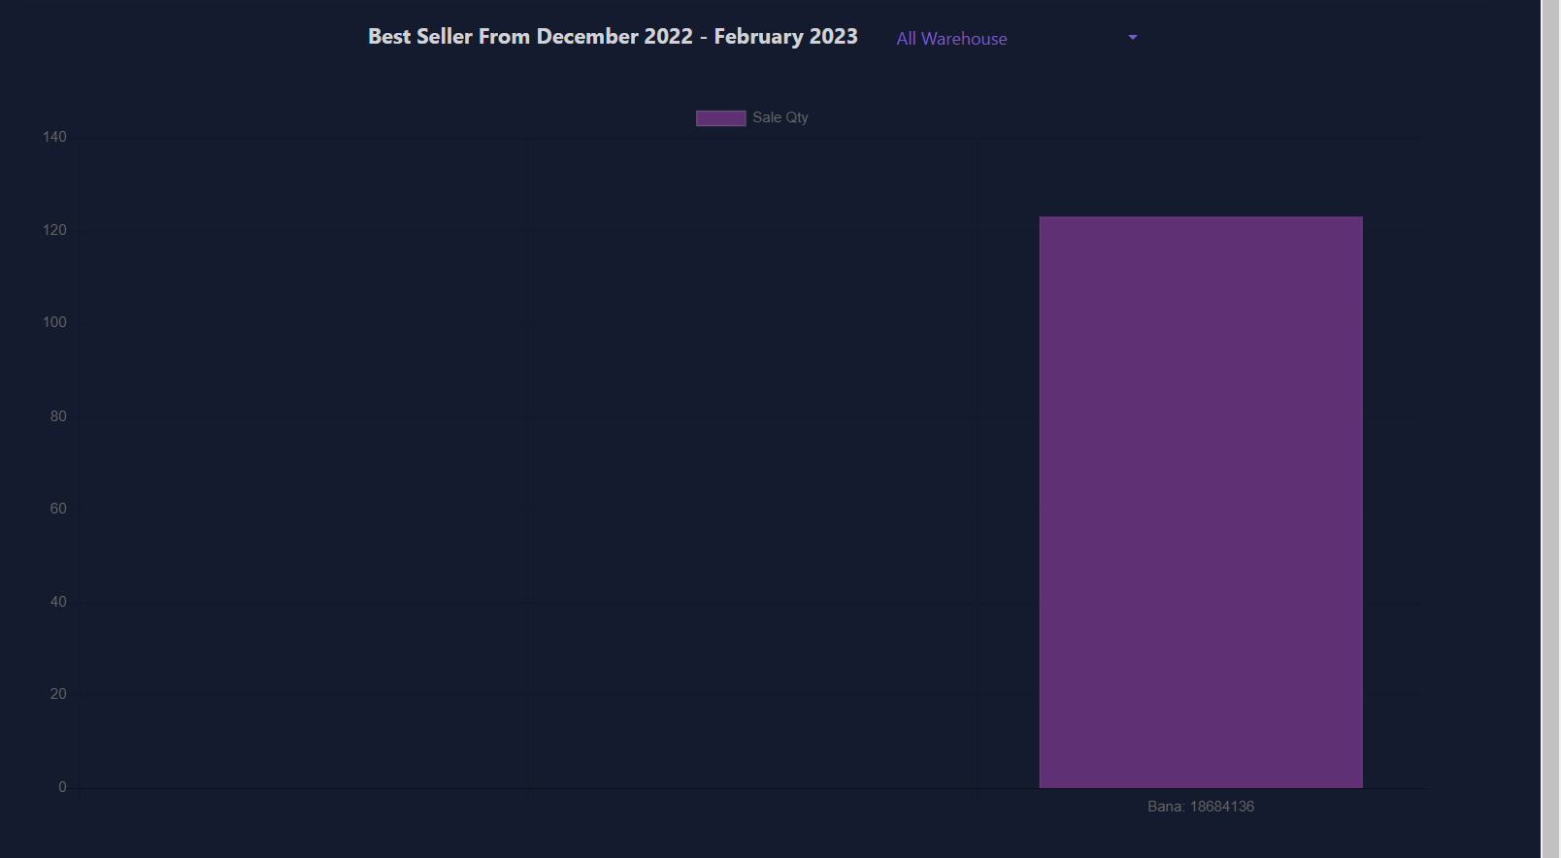
* **Product Report**
* 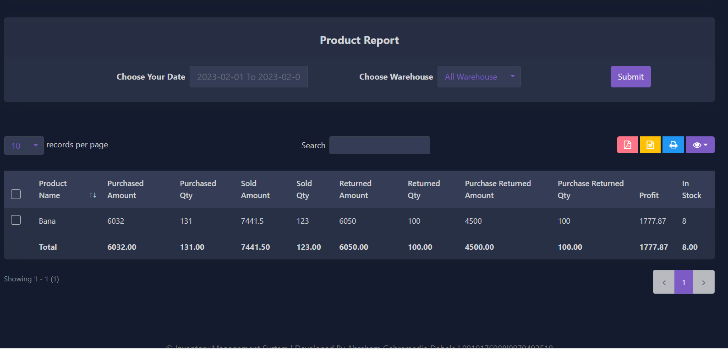
* **Daily Sale Report**
* 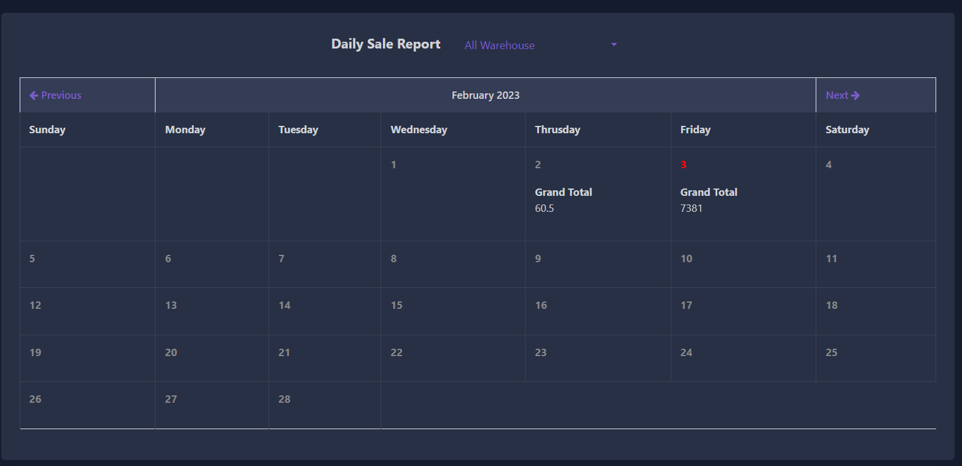
* **Monthly Sale Report**
* 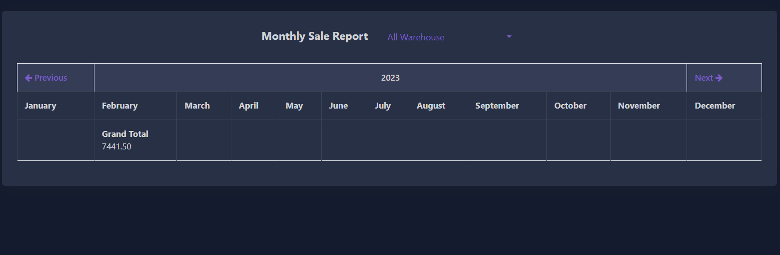
* **Daily Purchase Report**
* 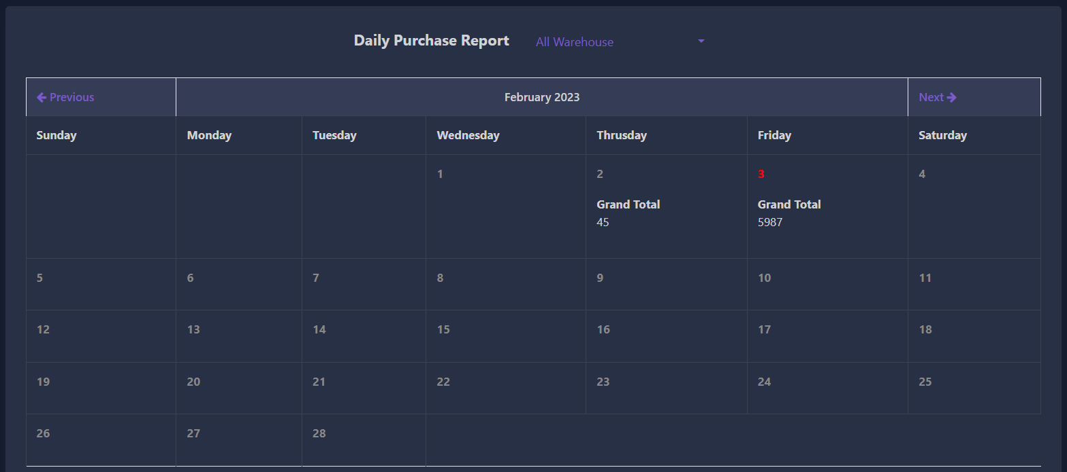
* **Monthly Purchase Report**
* 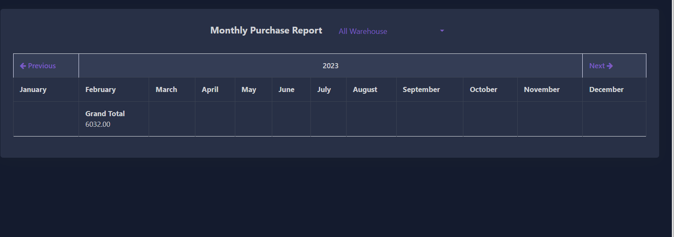
* **Sale Report**
* 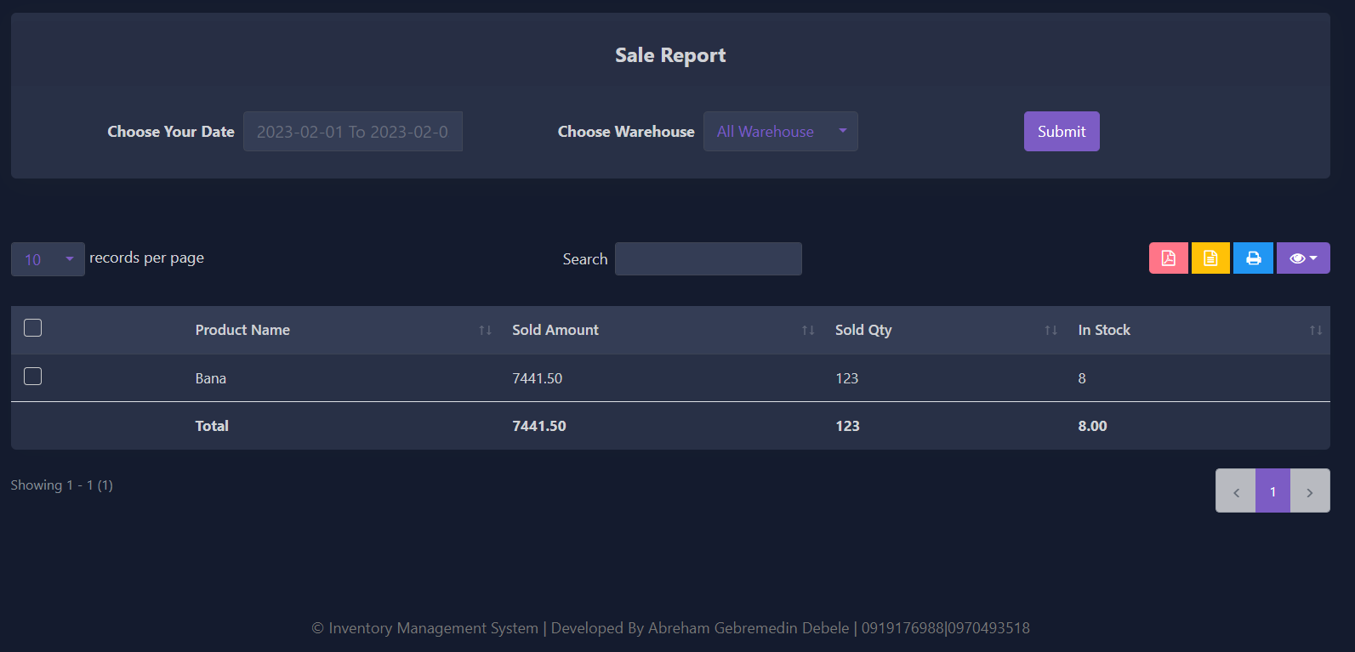
* **Sale Report Chart**
* 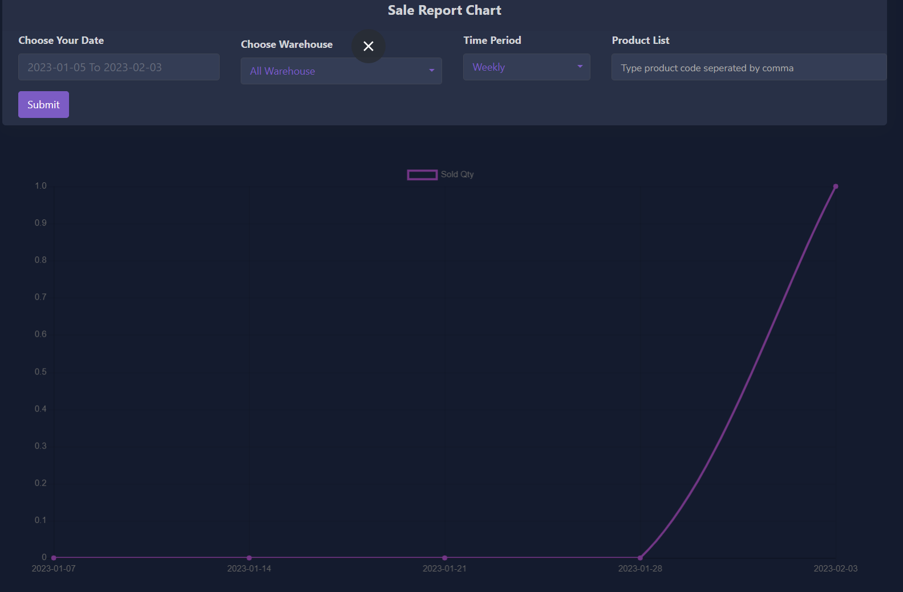
* **Payment Report**
* 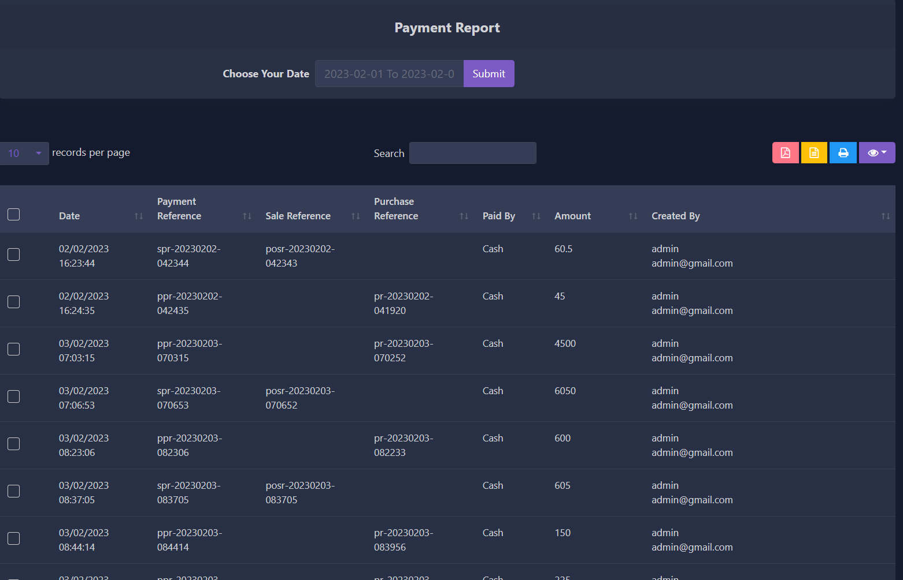
* **Purchase Report**
* 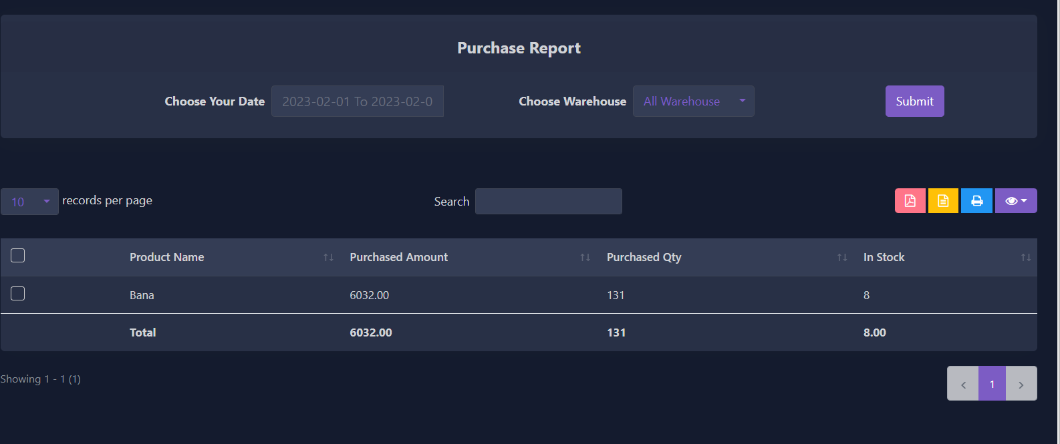
* **Warehouse Stock Chart Report**
* 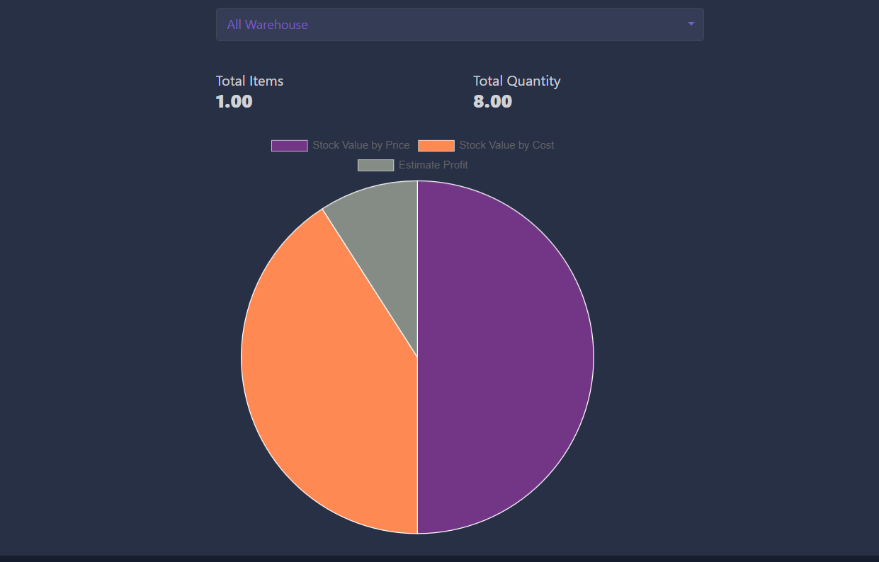
* **Product Quantity Alert Report**
* **Daily Sale Objective Report**
* **User Report**
* **Customer Report**
* **Customer sale report** 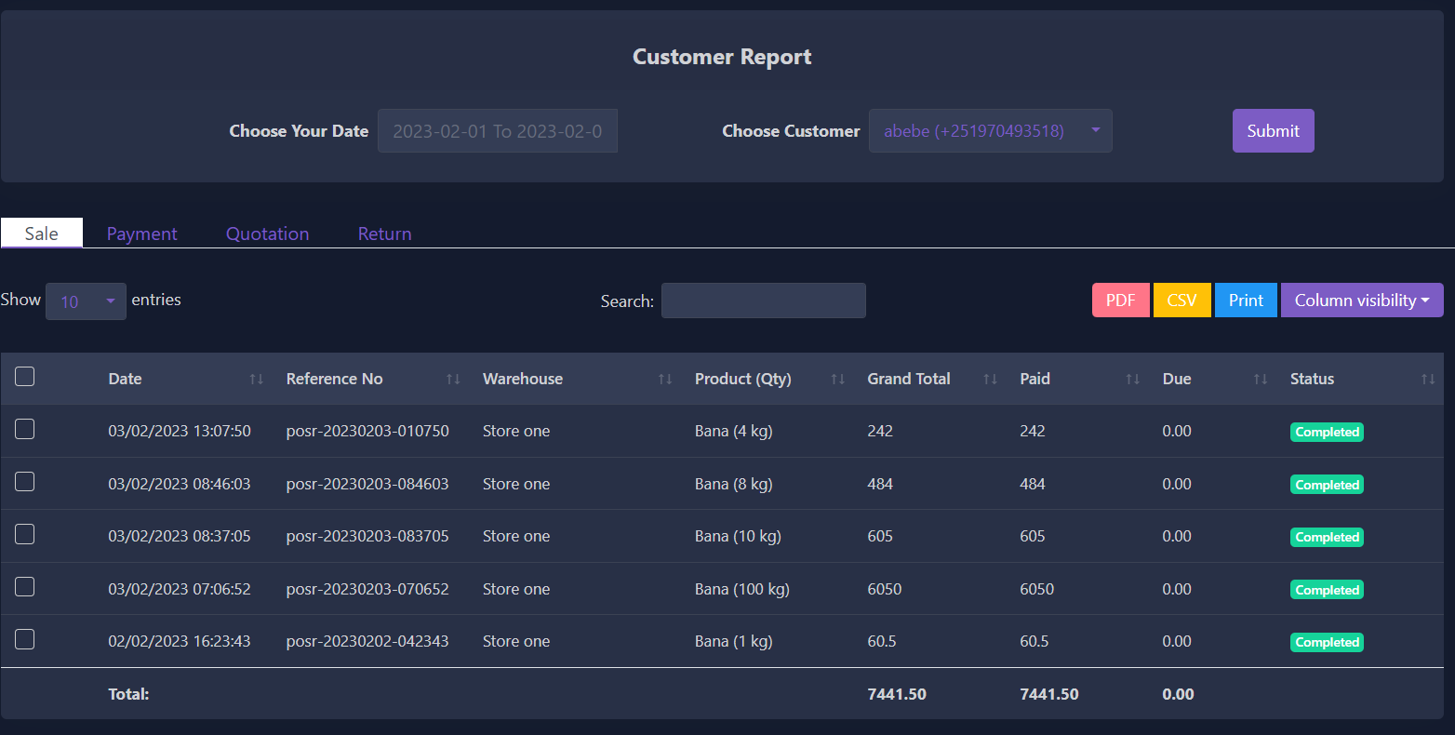
* **Customer payment report** 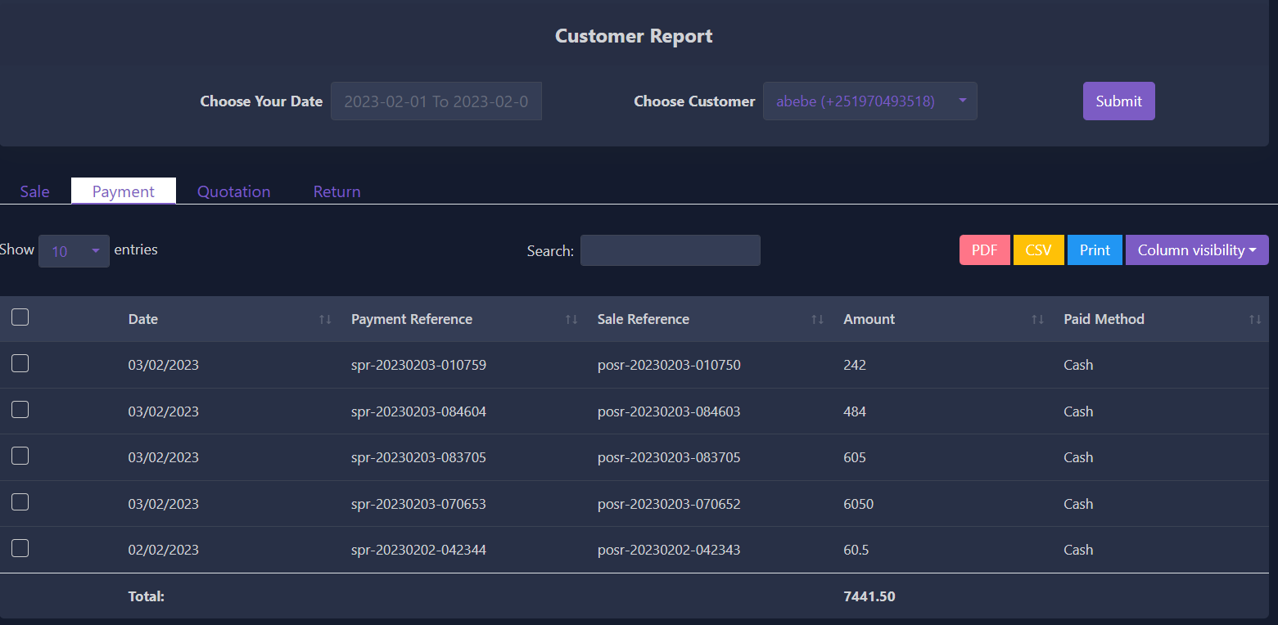
* **Supplier Report**
* **Due Report**

### Daily Sale Objective Alert

You can set daily sale objective for specific products. Meaning the minimum sold quantity for a product in a day. If the product cannot fulfill the objective user will be notified on the dashboard.

**Note:** If you face any issues while setting up cron jobs, please contact support.

### SETTINGS

## ****Add Role****

You can create, edit and delete user roles. You can controll user access by changing the role permission. So, under a certain role users have specific access over this software

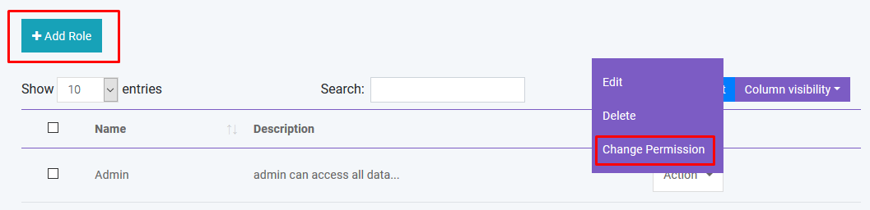

## ****Add Warehouse****

You can create, edit and delete warehouse. You can also import warehouse with CSV file. **You must follow the instruction to import data from CSV.**

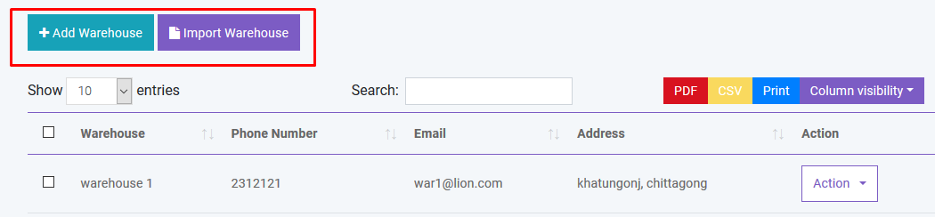

## ****Add Customer Group****

You can create, edit and delete customer group. Different customer group has different price over the product. You can modify this by changing price percentage in Customer Group module.

You can also import customer group with CSV file. **You must follow the instruction to import data from CSV.**

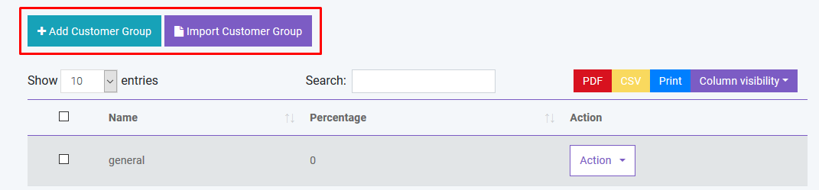

## ****Add Brand****

You can create, edit and delete product brand. You can also import brand with CSV file. **You must follow the instruction to import data from CSV.**

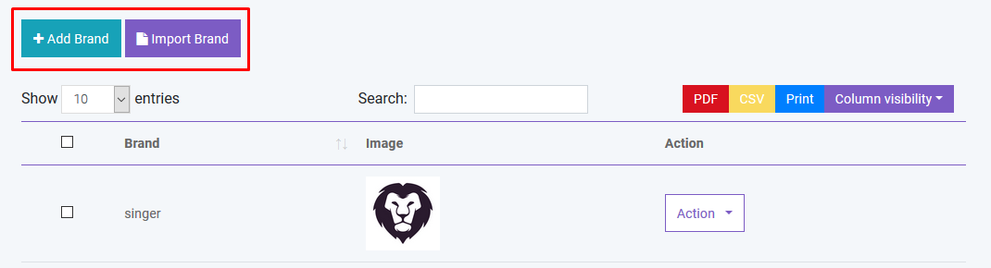

## ****Add Unit****

You can create, edit and delete product unit. You can also import brand with CSV file. **You must follow the instruction to import data from CSV.**

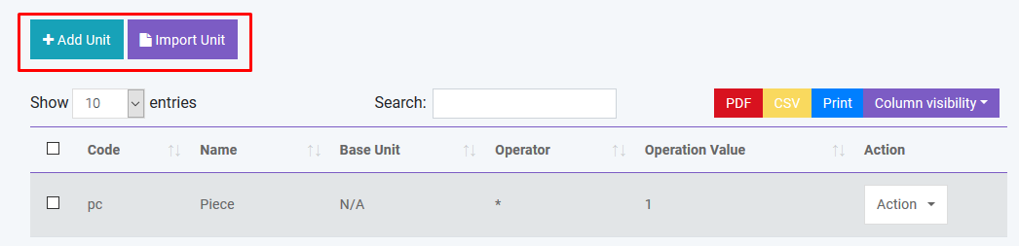

## ****Add Tax****

You can create, edit and delete different product tax. You can also import tax with CSV file. **You must follow the instruction to import data from CSV.**

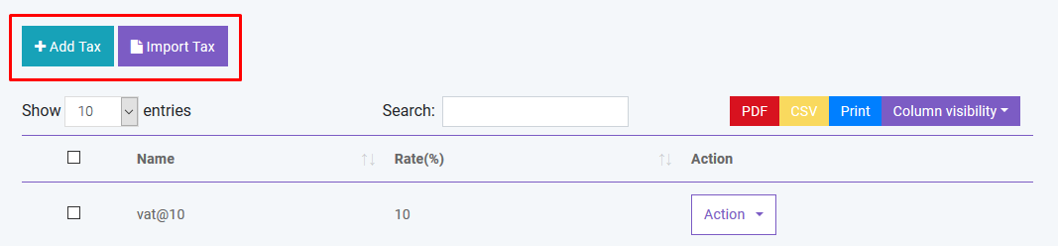

And you can search, export and print data from table that we discussed in [Product](http://localhost:85/Invosale/public/read_me/#product) section.

## ****General Settings****

You can change Site Title, Site Logo, Currency, Time Zone, Staff Access, Date Format and Theme Color from general settings

## ****User Profile****

You can update user profile info from this module

## ****POS Settings****

You can set your own POS settings from this module. You can set default customer, biller, warehouse and how many Featured products will be displayed in the POS module. You have to set your **Stripe** public and private key for Credit Card Payment. To implement payment with **Paypal** you have to buy live api from Paypal. You will also need to fillup the following information.

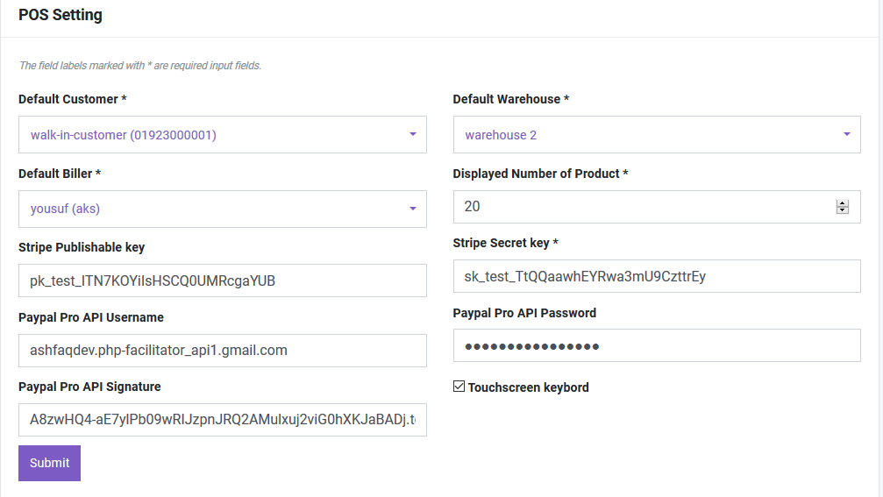

## ****HRM Setting****

You can set default CheckIn and CheckOut time in HRM Setting.

## ****SMS Setting****

You can use Bulk SMS service via **Twilio** and **Clickatell**. You just have to fill the information correctly to activate this service. **Please provide country code to send sms.**

*Copyright Warning*

***InvoSale*** *Software Documentation*

*This software documentation is the property of* ***InvoSale*** *Developer Mr. Abreham Gebremedin and is protected by Ethiopian and international copyright laws. No part of this documentation may be reproduced, distributed, or transmitted in any form or by any means, including photocopying, recording, or other electronic or mechanical methods, without the prior written permission of* ***InvoSale****.*

*The information contained in this documentation is confidential and intended solely for the use of authorized InvoSale client and authorized users of the InvoSale software. Unauthorized use, reproduction, or distribution of this documentation is strictly prohibited and may result in legal action.*

*All trademarks, trade names, logos, and service marks (collectively the "Trademarks") displayed in this documentation are the property of InvoSale or its respective owners. Nothing contained in this documentation should be construed as granting any license or right to use any Trademark without the written permission of InvoSale or its respective owner.*

*InvoSale reserves the right to make changes to the software documentation without notice. This copyright warning must be displayed on all copies of the InvoSale software documentation, in whole or in part, and must not be altered or removed in any way.*

*InvoSale*

*[Butajira, SNNPR, Ethiopia]*

*[+251919176988 | +251970493518]*

*[abrehamgebremedin12@gmail.com| Abreham.gebremedin@uog.edu.et]*